
Company
Logotype

Cone Beam Computed Tomography- Report



Porur Dental X-rays & CBCT

Patient Name : Mr. Ramesh | Date of Report : 19.05.2024
Age/ Gender : 70 years/ Male | Region of Interest : CBCT Full Skull
Referring doctor: Dr. Dany. A | Indication : Implant assessment
Clinical Notes: Nil
PATIENT INFORMATION

CBCT- Full Skull provided
CBCT – IMAGE DETAILS

RADIOGRAPHIC INTERPRETATION

- Complete loss of crown and root structure in relation to 16, 17, 18, 23, 24, 25, 26, 31, 32, 33, 34, 35, 36, 37, 38, 46.
- Fractured crown 11, 21.
- Root stumps in relation to 12, 13, 14, 15, 27.
- The alveolar ridge in relation to the maxillary and mandibular alveolar ridge is present with normal trabecular pattern.

IMPLANT ASSESSMENT

 | 11 region | 12 region | 13 region | 14 region | 21 region | 22 region | 23 region | 24 region
Sub-Crestal | 7.5 | 6.2 | 6.6 | 8.8 | 4.2 | 4.2 | 5.8 | 5.7
Mid- Crestal | 8.5 | 5.3 | 7.3 | 9.3 | 5.2 | 5 | 6.6 | 7.4
Distance between the alveolar ridge and Floor of the Nasal cavity (in mm) | 23.4 | 18.7 | 17.6 | 18.5 | 23.2 | 24.9 | 18.9 | 21

 | 15 region | 16 region | 17 region | 25 region | 26 region | 27 region
Sub-Crestal (in mm) | 5.7 | 7.3 | 8.7 | 6.6 | 9 | 10.2
Mid- Crestal (in mm) | 7.5 | 7.6 | 9.5 | 8.1 | 8.7 | 11.3
Distance between the alveolar ridge and floor of the maxillary sinus (in mm) | 19.9 | 10.8 | 9.6 | 14.6 | 12.3 | 7.9

 | 31 region | 32 region | 33 region | 34 region
Sub-Crestal (in mm) | 3.6 | 4.9 | 4.4 | 6
Mid- Crestal (in mm) | 4.5 | 5.3 | 5.8 | 6.7
Distance between alveolar ridge and the inferior border of mandible (in mm) | 32.5 | 33.3 | 31.5 | 32.2

 | 35 region | 36 region | 37 region
Sub-Crestal (in mm) | 6.2 | 6.2 | 7
Mid- Crestal (in mm) | 8.6 | 10.1 | 9.7
Distance between alveolar ridge and the inferior alveolar nerve canal (in mm) | 16.3 | 14.9 | 18
Distance between alveolar ridge and the inferior border of mandible (in mm) | 31.2 | 29.5 | 29.4

 | 46 region
Sub-Crestal (in mm) | 5.8
Mid- Crestal (in mm) | 8.6
Distance between alveolar ridge and the inferior alveolar nerve canal (in mm) | 15.2
Distance between alveolar ridge and the inferior border of mandible (in mm) | 31.3

RADIOGRAPHIC IMPRESSION

- Partially edentulous maxillary and mandibular arch.
- Fractured crown 11, 21.
- Root stumps in relation to 12, 13, 14, 15, 27.

Kindly correlate with clinical findings


IMAGES FOR REFERENCE

RECONSTRUCTED PANORAMIC VIEW

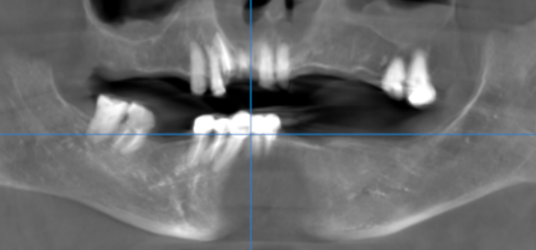

3-DIMENSIONAL VIEW

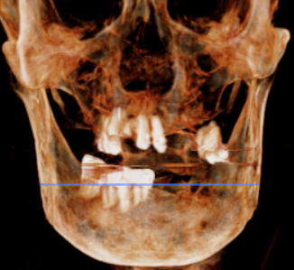

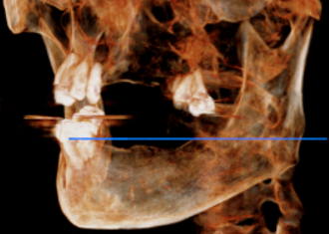

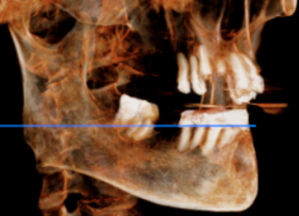

CROSS SECTIONAL VIEW

11 region | 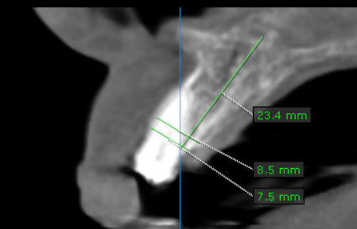
12 region | 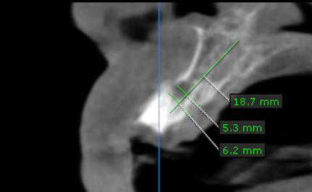
13 region | 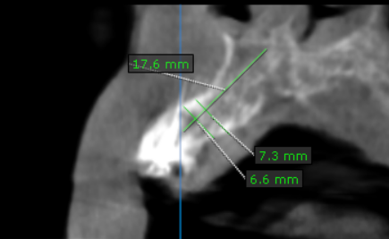
14 region | 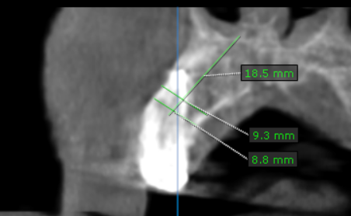
15 region | 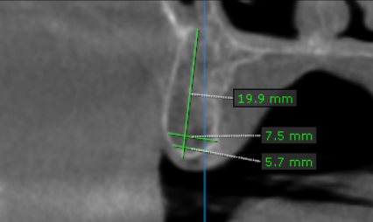
16 region | 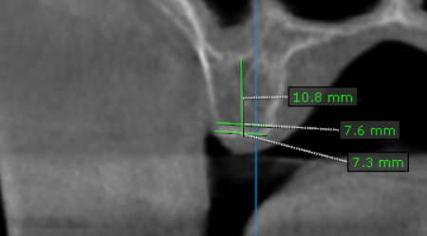
17 region | 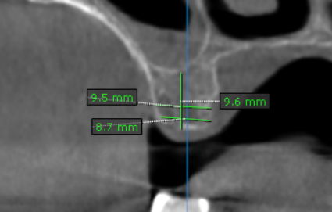
21 region | 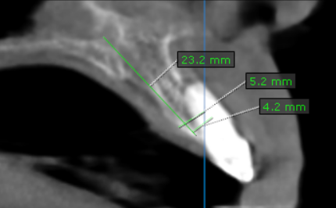
22 region | 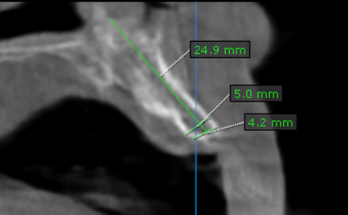
23 region | 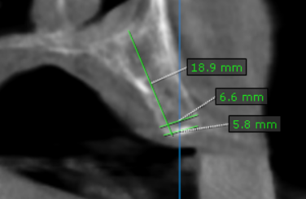
24 region | 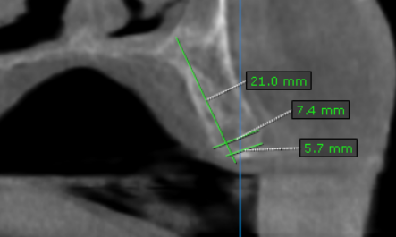
25 region | 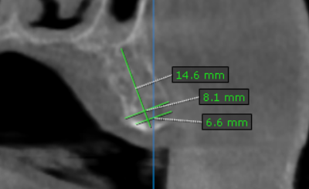
26 region | 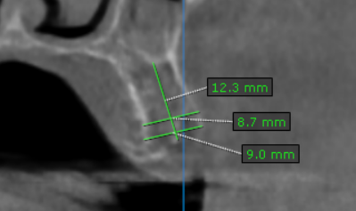
27 region | 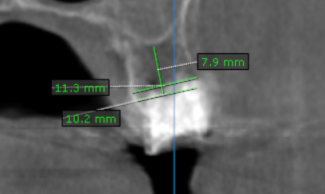
31 region | 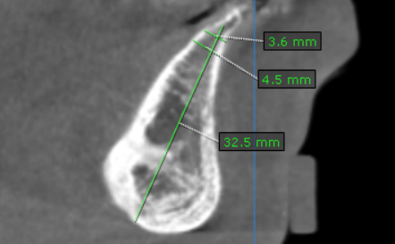
32 region | 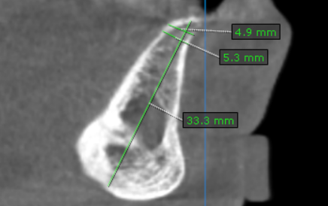
33 region | 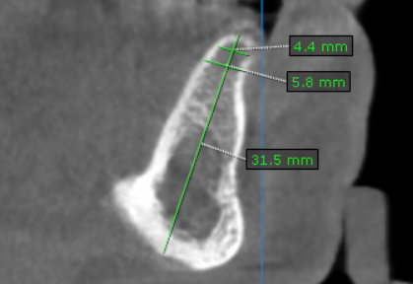
34 region | 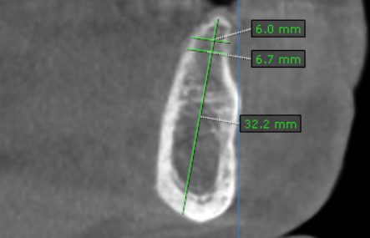
35 region | 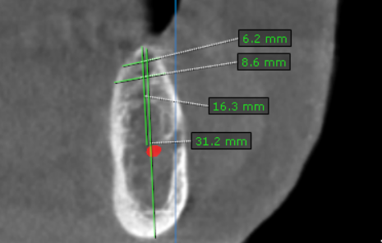
36 region | 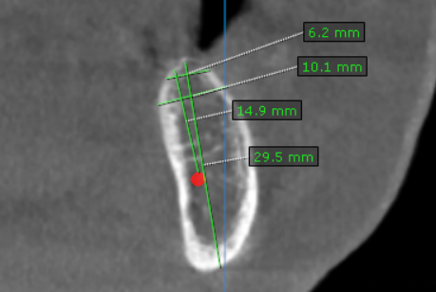
37 region | 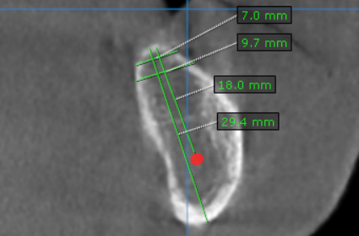
46 region | 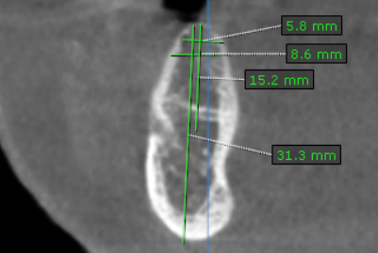

**** End of report ****

